Shell Scripting
What is Shell and Shell scripting?
A shell is a command-line interpreter that provides an interface for users to interact with an operating system (KERNEL).
It translates commands entered by the user into instructions that the KERNEL can understand and execute.
In Unix-like systems, common shells include Bash, Zsh, and Korn shell.
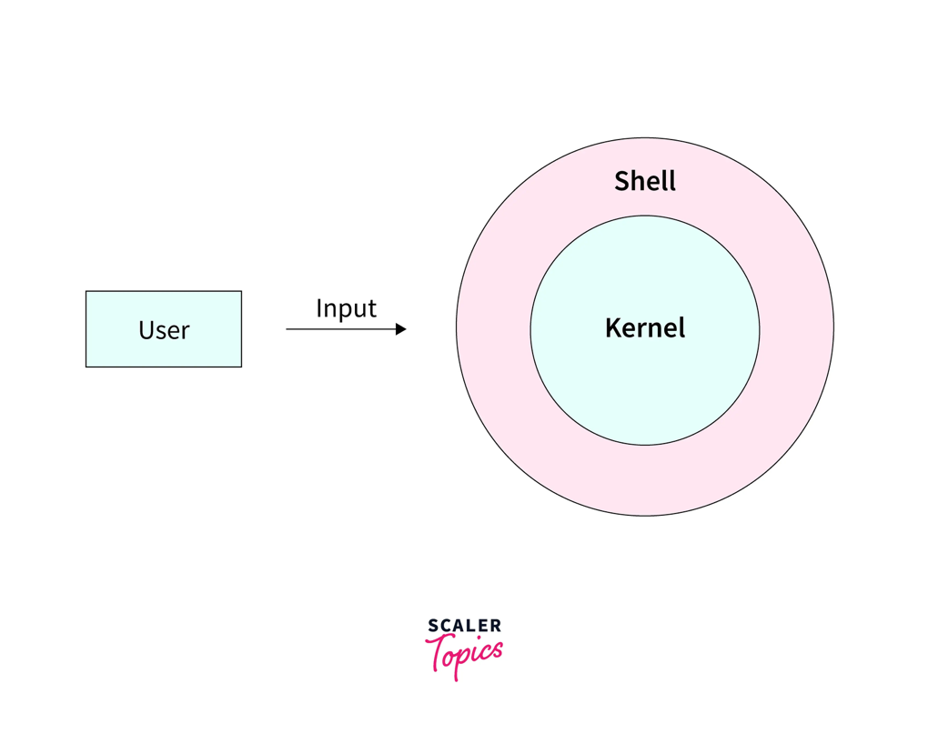
Shell scripting is the process of writing a sequence of commands in a text file using a shell's scripting language (e.g., Bash scripting)

Shell scripting is used to
- automate repetitive tasks.
- simplify complex operations and
- create custom tools or utilities.

It allows users to combine various commands, introduce conditional logic (if-then statements), loops, and functions to create powerful and efficient workflows.

In essence, the shell is the environment where commands are executed, while shell scripting is the method of automating those commands by grouping them into executable files.

Difference between scripting and programming
Programming Language:
- Compilation: Typically requires a compilation step, where the source code is translated into machine code (or an intermediate bytecode) before execution. This compiled code can then run independently.
- Purpose: Designed for building standalone, complex applications and systems from the ground up, offering fine-grained control over hardware and system resources.
- Examples: C, C++, Java, Rust, Go.
Scripting Language:
- Interpretation: Generally interpreted, meaning the code is executed line by line by an interpreter at runtime, without a separate compilation phase.
- Purpose: Primarily used for automating tasks, extending the functionality of existing applications, or "gluing" together different software components. They often operate within a host environment.
- Examples: Python, JavaScript, Ruby, Perl, PHP, Bash.

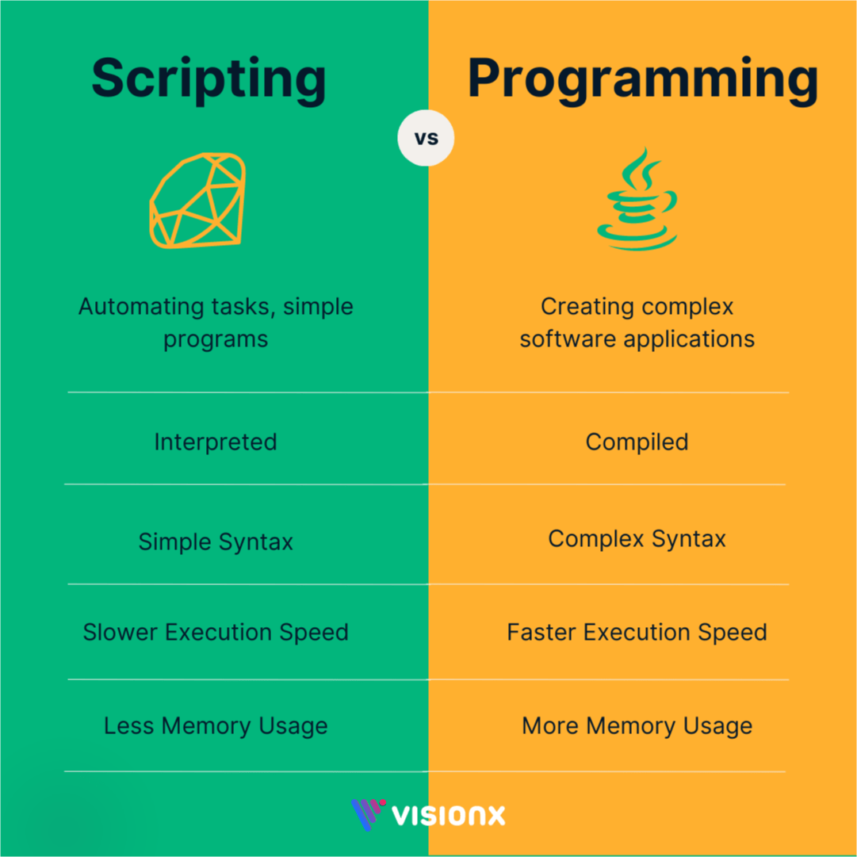
Shell Variables:
Shell variables are named entities within a shell environment that store values, acting as containers for data. These values can be strings, numbers, or other data types.

When a shell is running, three main types of variables are present –

Local Variables − A local variable is a variable that is present within the current instance of the shell. It is not available to programs that are started by the shell. They are set at the command prompt.

Environment Variables − An environment variable is available to any child process of the shell. Some programs need environment variables to function correctly. Usually, a shell script defines only those environment variables that are needed by the programs that it runs.

Shell Variables − A shell variable is a special variable that is set by the shell and is required by the shell to function correctly. Some of these variables are environment variables whereas others are local variables.

How to use SHELL variables:
- Definition and Assignment: Variables are defined by assigning a value using the syntax VARIABLE_NAME=value. No explicit type of declaration is required.

Code
MY_VARIABLE="Hello World"
COUNT=10
- Naming Conventions: Variable names can contain letters (a-z, A-Z), numbers (0-9), and underscores (_). They must start with a letter or an underscore and are case-sensitive.

Code
_valid_name="Valid"
INVALID-NAME="Invalid" # Invalid character '-'
1_INVALID="Invalid" # Cannot start with a number
- Accessing Values: To retrieve the value stored in a variable, prefix its name with a dollar sign ($).

Code
echo $MY_VARIABLE # Outputs: Hello World
echo "The count is: $COUNT" # Outputs: The count is: 10
- Scope: By default, shell variables are local to the current shell or script in which they are defined. They are not automatically inherited by child processes (subshells or executed commands).
- Environment Variables: To make a shell variable accessible to child processes, it must be "exported" using the export command. Exported variables are known as environment variables.

Code
export MY_ENV_VAR="This is an environment variable"
- Operations: Shell variables can be used in various operations, including string concatenation and arithmetic calculations.

Code
FIRST_NAME="John"
LAST_NAME="Doe"
FULL_NAME="$FIRST_NAME $LAST_NAME"
echo $FULL_NAME # Outputs: John Doe
NUM1=5
NUM2=3
SUM=$((NUM1 + NUM2))
echo $SUM # Outputs: 8

- Unsetting Variables: Variables can be removed from the shell's memory using the unset command.

Code
unset MY_VARIABLE

